Thank you both for working so hard with me during our session. I can now present the results of our discussion in the chart below and the suggested targets and strategies to use with J in his CAP Intervention Plan. (The total score for each domain or area is based on the average of the individual scores agreed for each ability within that domain/area).

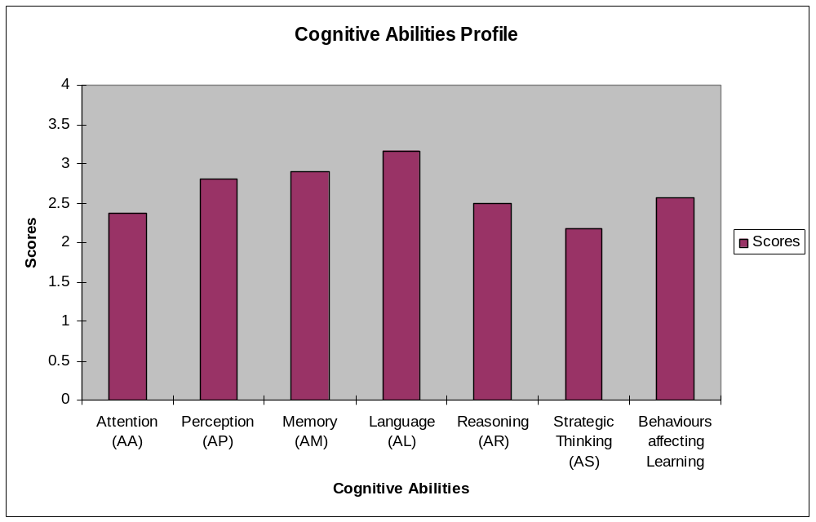

Attention | Perception | Memory | Language & Communication | Reasoning/ Logic | Strategic Thinking | Learning Behaviours
2.37 | 2.8 | 2.9 | 3.16 | 2.5 | 2.18 | 2.56

N | 1 | 2 | 3 | 4
Not observed/Not applicable | Not able, even with support | Only able with support | Sometimes able/inconsistent | Independently able

Please note that CAP scores are not standardised i.e. they are not intended to reflect J’ performance in comparison to other children. The graph provides an “at a glance” picture of J’ relative strengths and needs across some important domains of thinking.

The profile identifies J’ areas of strength as language, memory and perception. Areas to work on are also clearly identified as reasoning/logic, strategic thinking/ metacognition and behaviours affecting learning. Please see below for further information on these areas and suggested targets.
In addition, from our discussion I think that a focus on improving J’ attention skills and developing his self-esteem as a learner should also be part of work with J in school and at home as they are very important factors in learning.

Reasoning skills
This refers to the child’s ability to connect pieces of knowledge and experience and make predictions. A child who is not able to think logically may have fragmented thinking, where learners may have pieces of knowledge, but they are disconnected. When this area is targeted for development, the learner may show increased capacity for logical thinking that was not previously evident in their independent working. In developing logical reasoning, the teacher draws together prior knowledge and experience, helps to structure their thinking and teaches the child how predictions are made based on their understanding of logically related event and concepts.

Target 1
- To develop J’ ability to compare objects and groups of objects systematically e.g. in what ways are they the same or different?

Why chose this area to work on?
- Comparison is the basis for logical reasoning and underpins many other cognitive abilities.
- J’ scored 2 for comparing items/concepts in a systematic way (one of his lowest scores).

Strategies:
  - Ask the child to organise objects into different groups and give those groups a name e.g. according to colour, shape, size, types of object e.g. cars vs. animals etc
  - Ask why he put an object in that group?
  - Take 2 objects and ask ‘why are they the same?’
  - Take 2 different objects and ask ‘Why are they different?’
  - Put an object in the wrong group ask ‘why doesn’t it belong’ etc
  - Please see pages 182 and 183 of the manual scanned in for you for further information and examples of strategies.

Strategic thinking and metacognition
Metacognition is the ability to reflect and consider your own thinking and look at the strategies you are using and how helpful they are. It is an important area as it is the quality of insight that leads to a learner being able to act independently in problem solving and move away from reliance on adult support. It also enables the learner to generalise their learning to different situations. Strategic thinking enables the learner to solve problems more effectively through understanding what they need to do to complete a task, selecting what is relevant, creating and testing hypotheses and planning.

Target 2
- To develop J’ ability to distinguish what is relevant and irrelevant to the task.

Why chose this area to work on?
- Seeing the relevance of information allows us to focus on the important bit without becoming confused or distracted by large quantities of information.
- Work in this area will also support J’ planning skills (see below).
- J’ scored 2 for selecting what is relevant to the task (one of his lowest scores).

Strategies:
  - Discuss ‘What do we need to do here?’
  - What information can we ignore?
  - What’s the most important thing to think about?
  - Why do we not need X for this task (encourages J to think about why he is selecting or dismissing information).
  - If there are a few important things, should they be done in a certain order?
  - These questions could be typed out on a prompt sheet for J. If laminated, he could fill it in and this would provide an initial plan for his work (see planning target below).

Target 3
- To develop J’ planning behaviour

Why chose this area to work on?
- Many learners are unaware of the need to plan and dive in without refection. They may be anxious or unaware of the need for planning. This important skill can be internalised and used spontaneously by the learner.
- J’ scored 2 for systematic planning behaviour (one of his lowest scores).

Strategies:
  - Explain what we mean by planning
  - Give lots of examples of planning in everyday life, for example, planning to go on holiday or a trip out, planning to go shopping, planning a football game with friends, planning a piece of work.
  - Have a planning sheet or white board available for J. Encourage them to write out the steps of the plan and to follow the order one step at a time.
  - Do not expect J to keep a plan in their heads. Explain that when we write things down, we don’t have to keep all our ideas in our heads. Also when we forget, we can just check our plan.
  - Point out timetables used in class or outside school and explain that a timetable is a plan of what we/activities/events or trains etc are happening/starting and when.
  - Use mind maps to plan for information needed to include in a story or piece of factual or topic based writing, building on J’ visual strengths.
  - Flow charts are also helpful in breaking down a task into a series of steps e.g. in maths and science and will provide a reminder of each step carried out and what to do next if J becomes distracted and forgets where he is with his work.
  - When building Lego models, encourage J to plan what he wants to do and what steps he might need to follow e.g. check certain key pieces are there, decide on whether features such as windows are important to build in etc.
  - Talk about making plans and how they are helpful. Show J that they are used in lots of ways and encourage him to use planning behaviour in different situations.
  - Use a plan to encourage checking and self-monitoring e.g. J can tick off what he has done and then clearly see what is left to do.

I am very interested in how you get on with J. Please get in touch if you would like any further explanation or advice or if you have any questions about how to implement this plan. If leave me a message on 0207 527 5817 I will get back to you as soon as I can.

XXX
Educational Psychologist 23/03/11

